Table seating company that rents tables to customers,

Object oriented, requires at minimum a Table object, containing First Name, Last Name, and Amount paid.

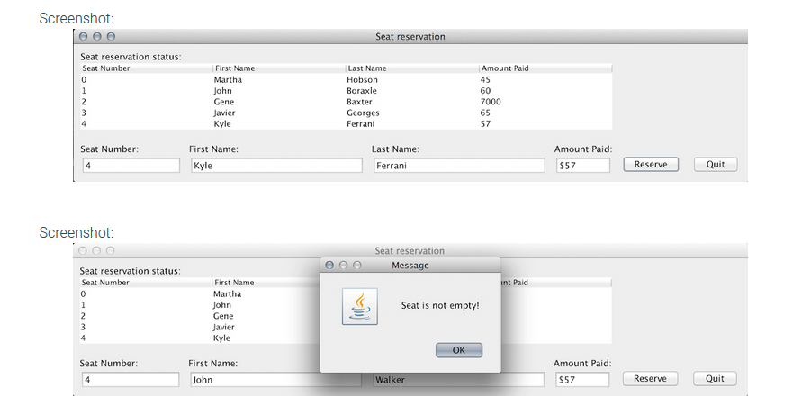

Must print a bill

ArrayList to store objects.

JFrame base

ListBoxes so the ArrayList Populates the listboxes.